Letcher County Extension

Newsletter

April 2024

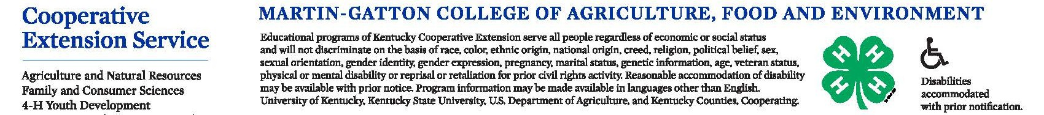
EXTENSION EVENTS
How to stay up-to-date?

Monthly Newsletter
Call or email to be added to the monthly mailing list
Facebook Page
“Like” our Facebook page-Letcher County Cooperative Extension Service :
Go to our page & check out events.
Webpage
Check out the county webpage at https://letcher.ca.uky.edu
Letcher County Extension

Email: letcher.Ext@uky.edu

Open Monday-Friday 8 am-4:30pm

478 Extension Dr Whitesburg, Ky 41858

Phone: 606-633-2362

PLEASE CALL TO REGISTER FOR EACH PROGRAM 633-2362 (LIMITED SPACES)

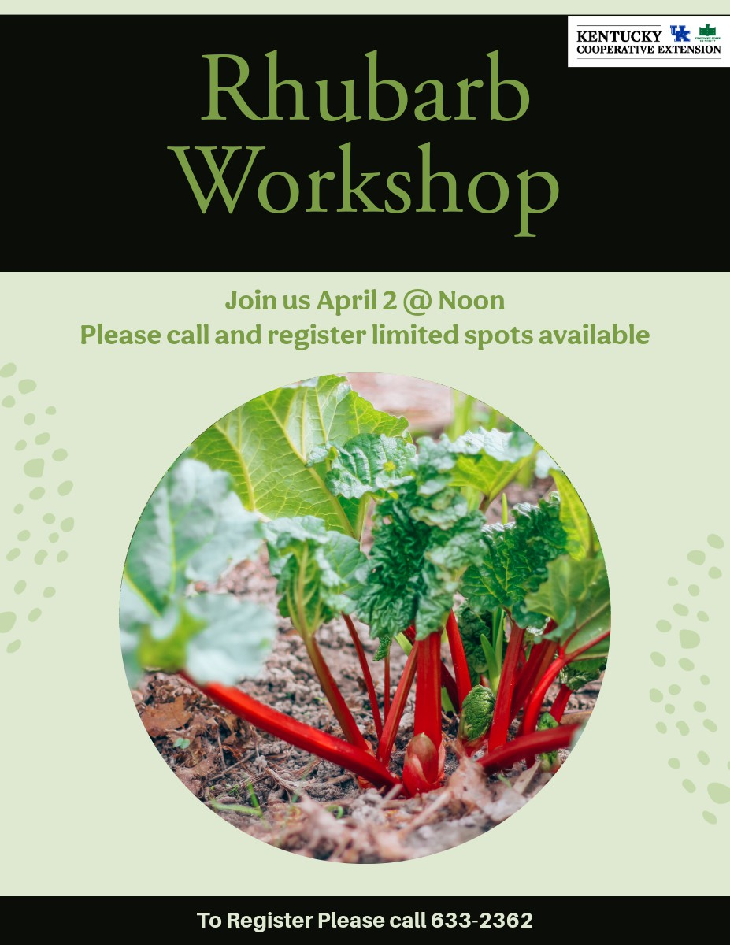
Strawberry Workshop April 3 @ Noon
Beekeepers Meeting April 9th @ 6:00

Composting Workshop April 24th @ Noon

PLEASE CALL TO REGISTER FOR EACH PROGRAM 633-2362 (LIMITED SPACES)
Clients participating in the spring flower workshops will receive a free hydrangea at the April 23rd workshop if you attend all workshops,

Spring Flower
Hyacinth Workshop
April 9th@ Noon

Participants must attended all of the spring flowers workshops to receive a Hydrangea
Spring Flowers
Daffodils Workshop
April 4 @ Noon Letcher County
Extension Office

Spring Flower Tulips Workshop
April 11th @Noon
Spring Flower Hydrangea
Workshop
April 23rd @ Noon

Shad Baker
Ag & Natural Resources Agent
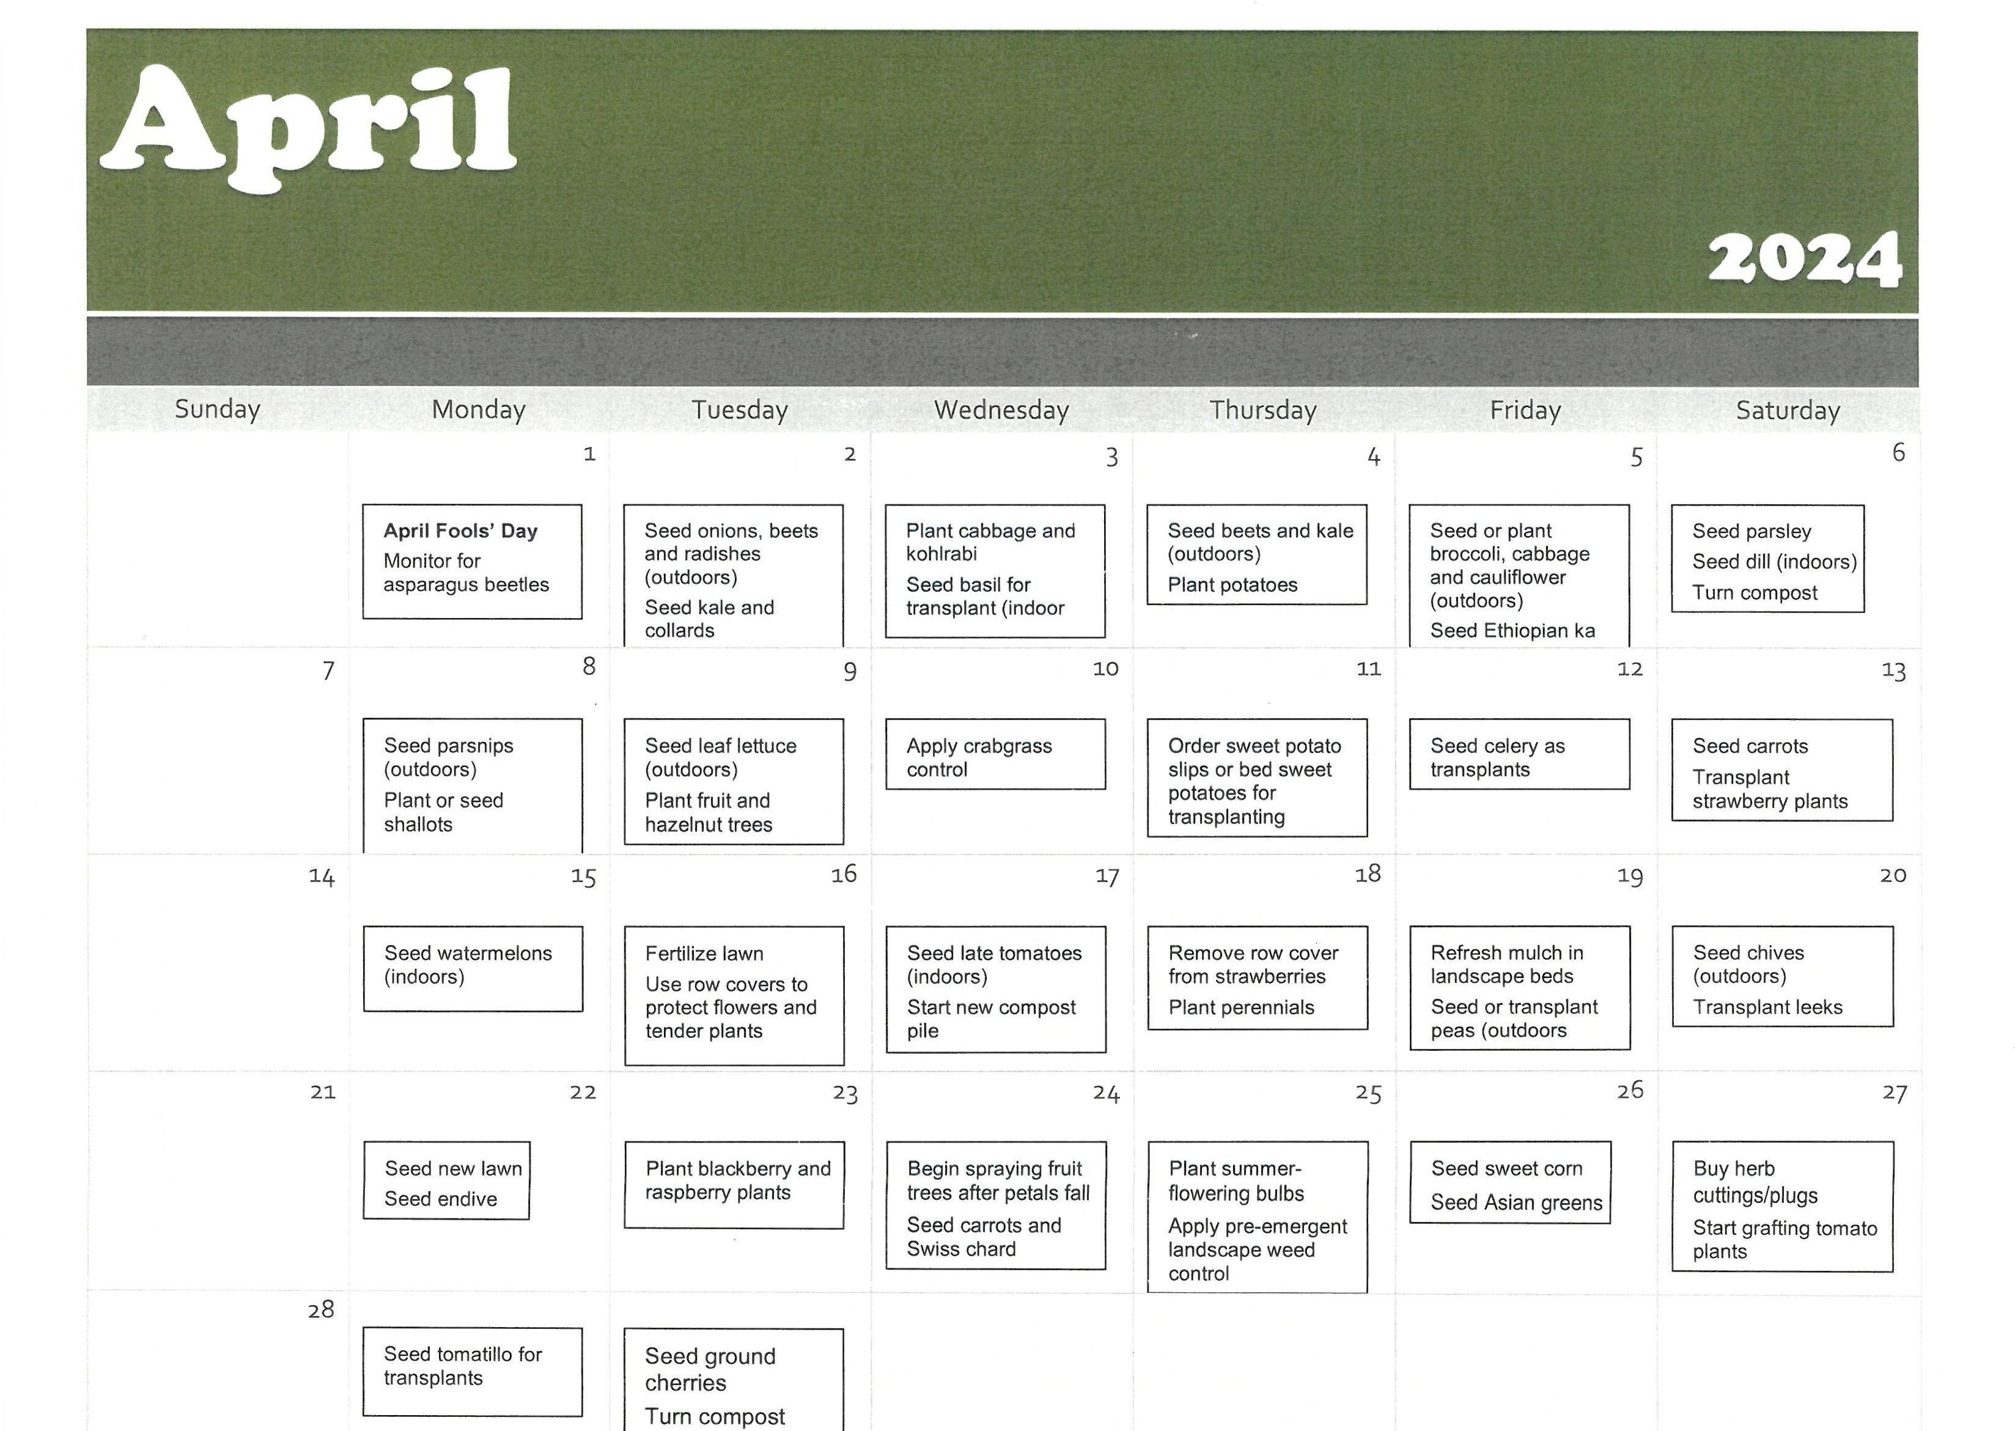

Martin-Gatton
Ye
College of Agriculture, Food and Environment University of Kentucky.

PLEASE CALL TO REGISTER FOR EACH PROGRAM 633-2362 (LIMITED SPACES)

Homemakers Council Meeting
April 18th @ 11:00
Letcher County Extension Office

Overnight Oats Workshop
April 23rd @ 1:00 pm
Recipes, learn how to make a base that can be used with any toppings, easy grab-n go breakfast pre-register by April 16th

This lesson will cover steps for food safety and fire safety when cooking outdoors. Participants will explore various categories of outdoor meals such as picnics, front country camping (at established campsites), and backcountry camping (more remote, undeveloped campsites). Enjoy seeing outdoor equipment like the Cast Iron Dutch oven that has been around for generations. Have fun also exploring ways to cook and bake outdoors. Vicki Boggs, Leslie County FCS agent, will be presenting this lesson. Pre-register by April 16th for catering.
S
a
f
e
O
u
t
d
o
o
r
C
o
o
k
i
n
g
L
u
n
c
h
n
L
e
a
r
n
H
e
a
l
t
h
y
&

April 18 @ Noon

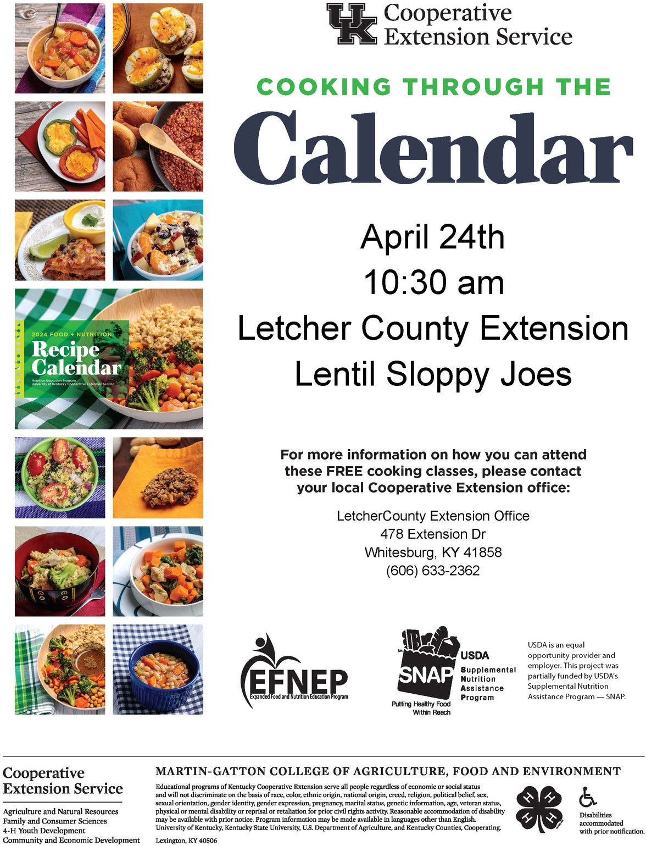
PBPT TRAINING
April 23rd 5:00
Letcher County Extension
call & register by April 19th

Composting Workshop April 24th @ Noon

Jenkins Homemakers
Meeting April 11th @ 11:30
Jenkins Library
Cowan Homemakers
April 11th @ 11:00
Cowan Community
Center

Crafty Cut-Ups Meeting
April 9th @ 10
Letcher County
Extension
Letcher Area Homemakers Meeting
April 9th @ 10:30 Jeremiah Baptist

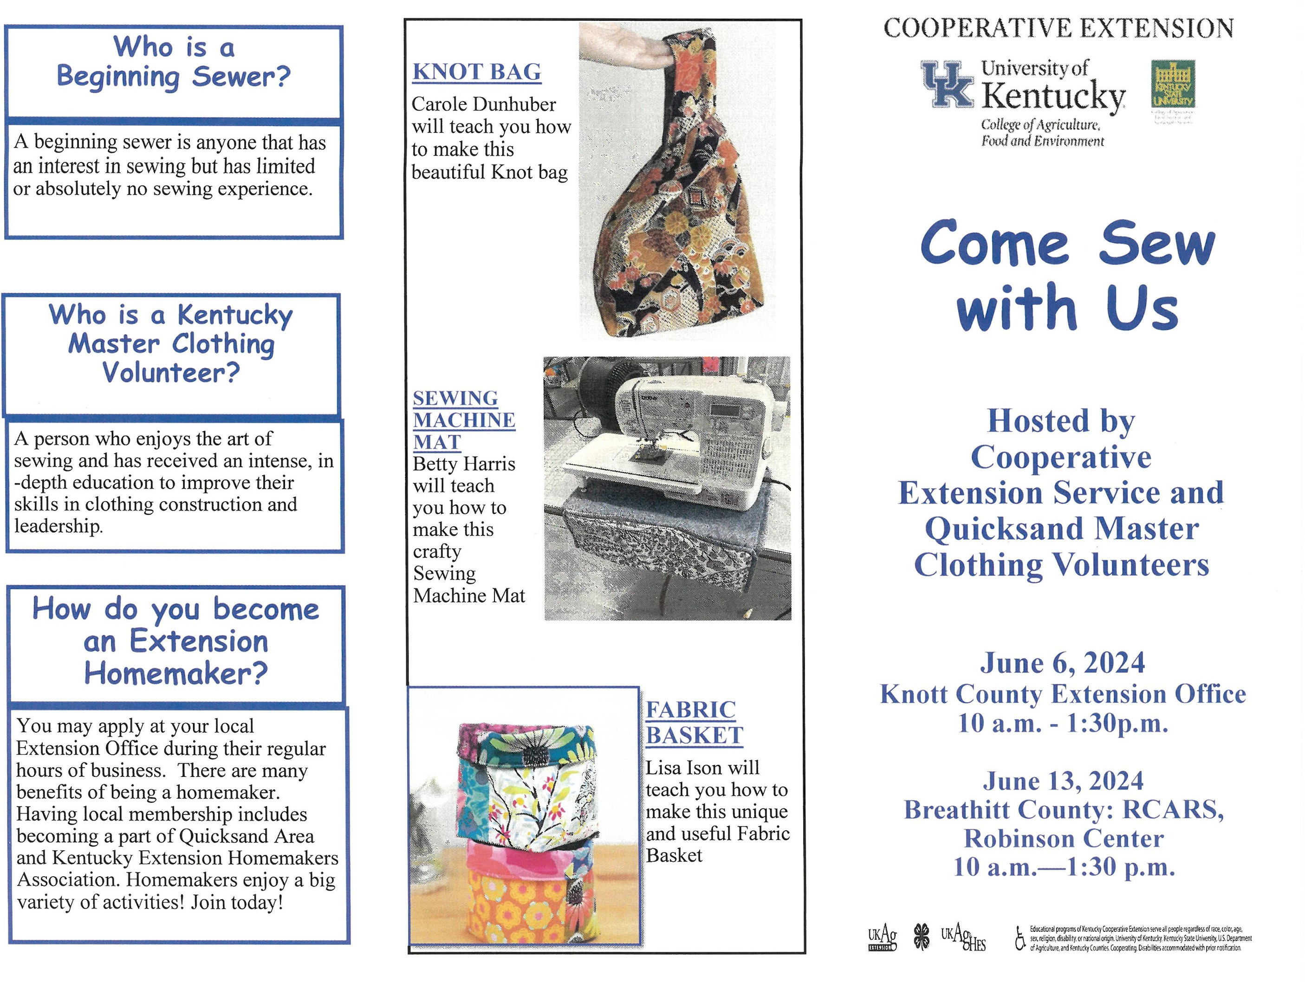

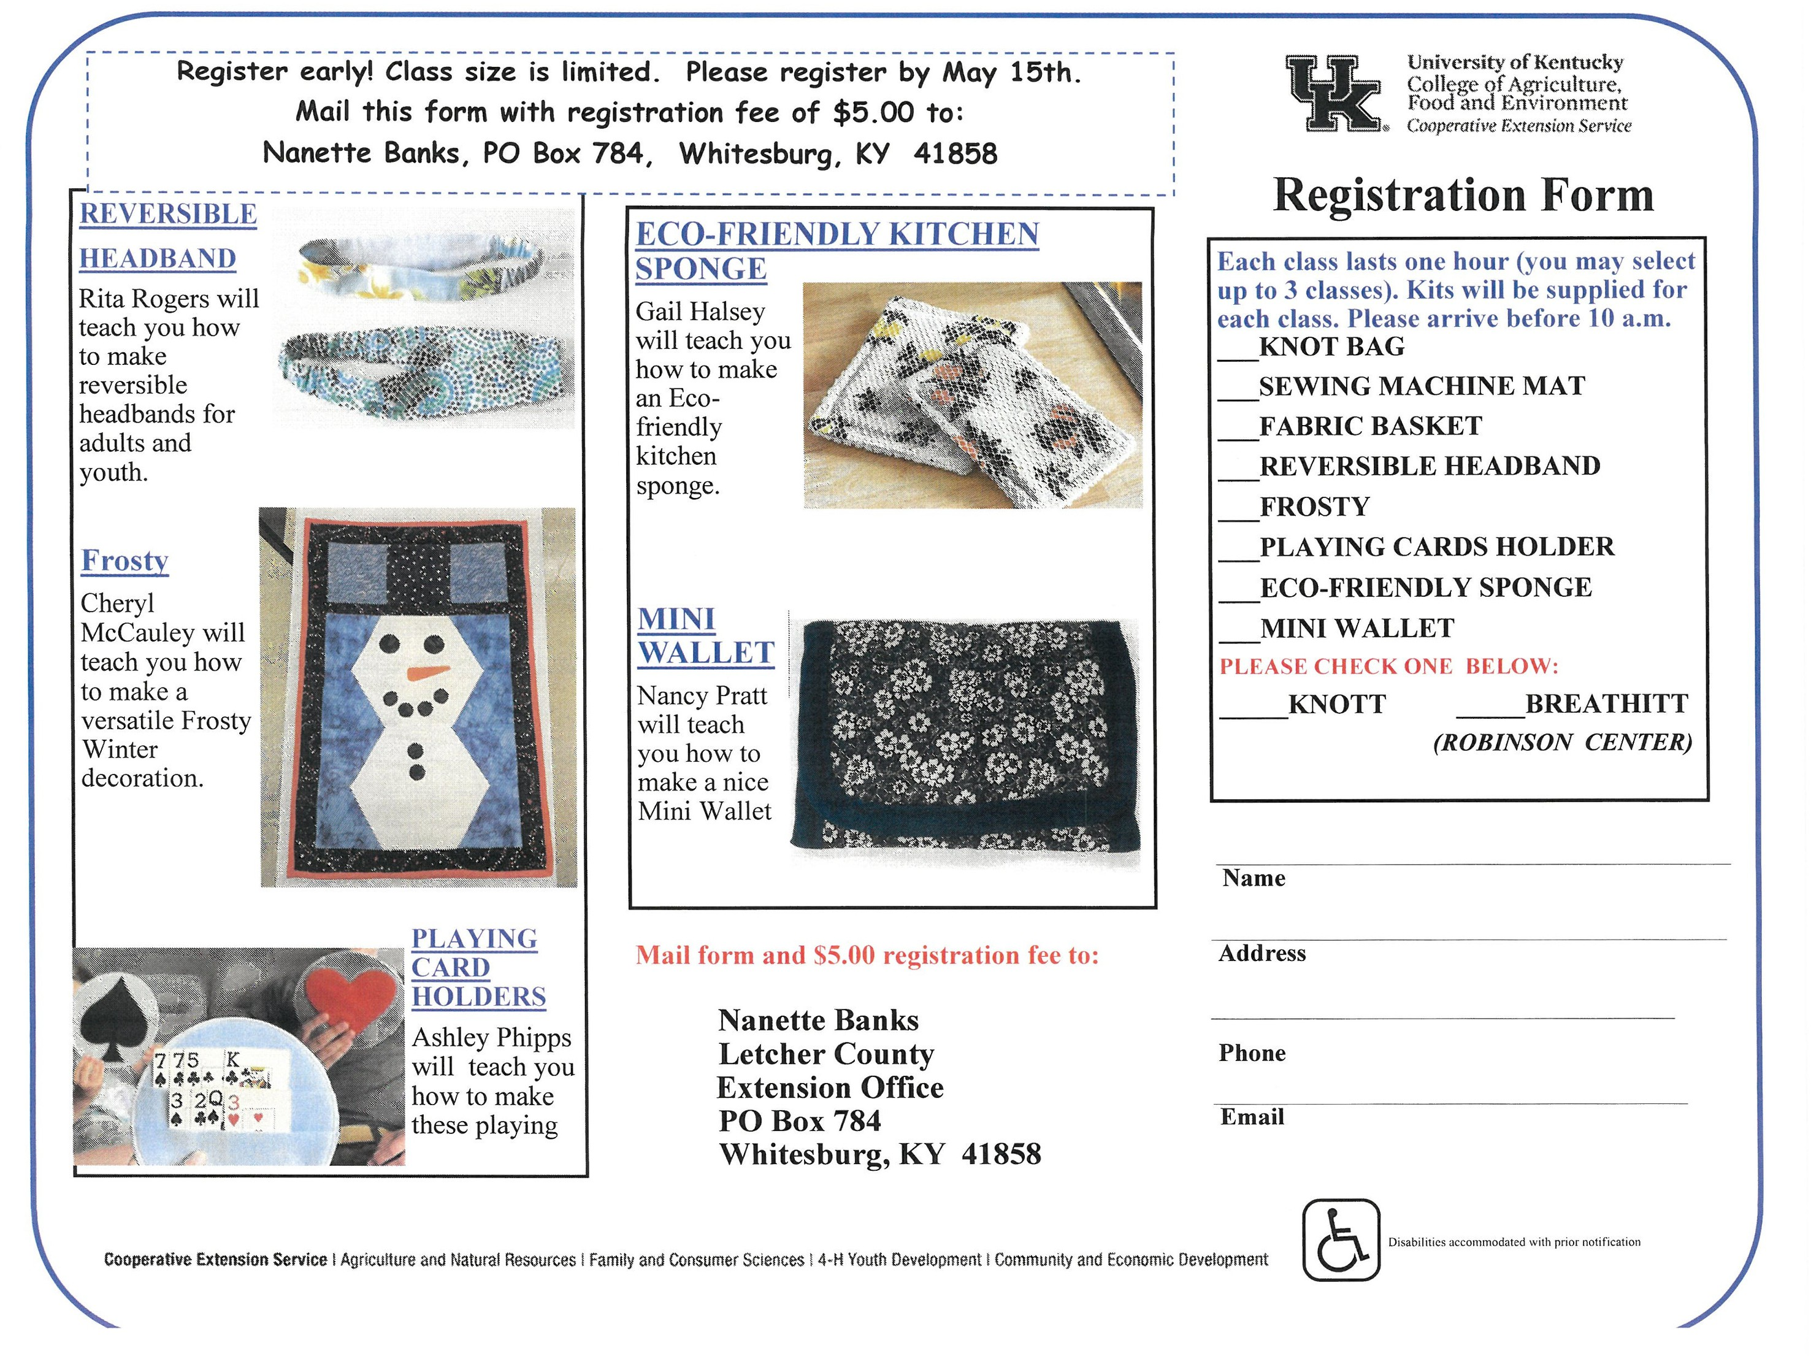

Orders must be turned in 4-23-24 Pick up date 4-30-24

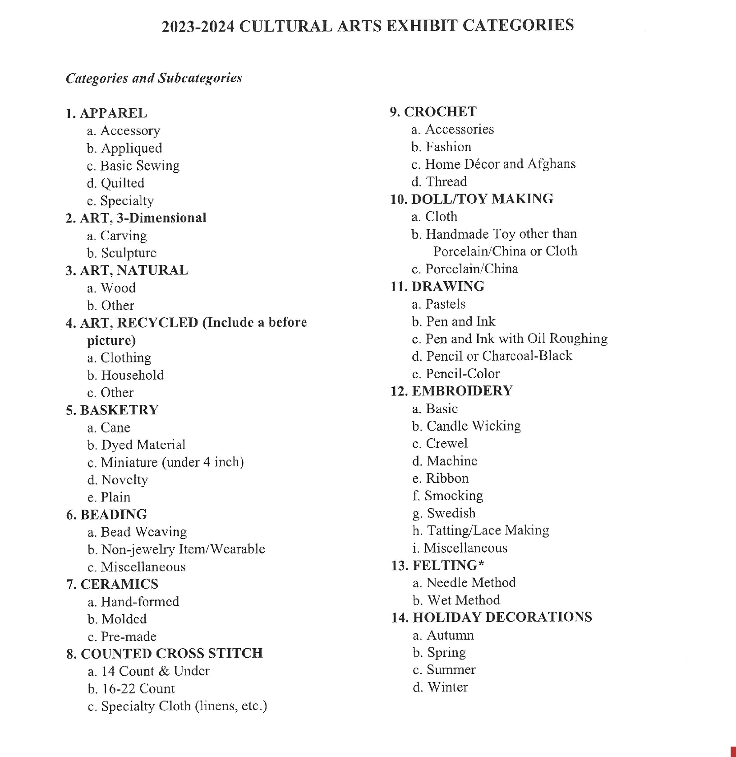

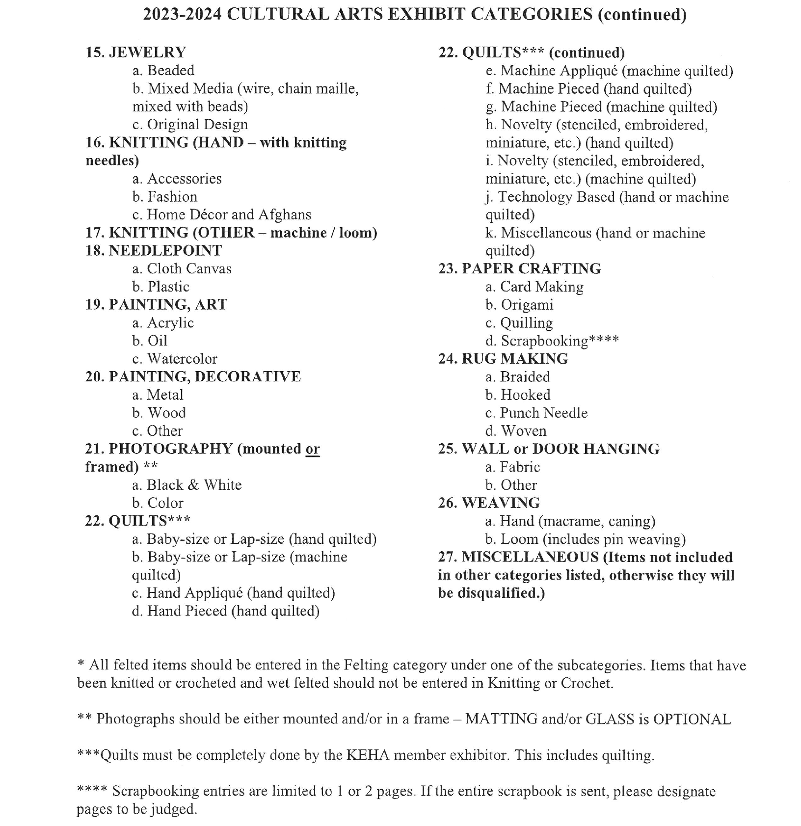

Homeschool Club
April 29th @ 1:00

Art Club
April 30th @ 3:30

Teen Club April 17 @ 3:30
Letcher County
Extension Office

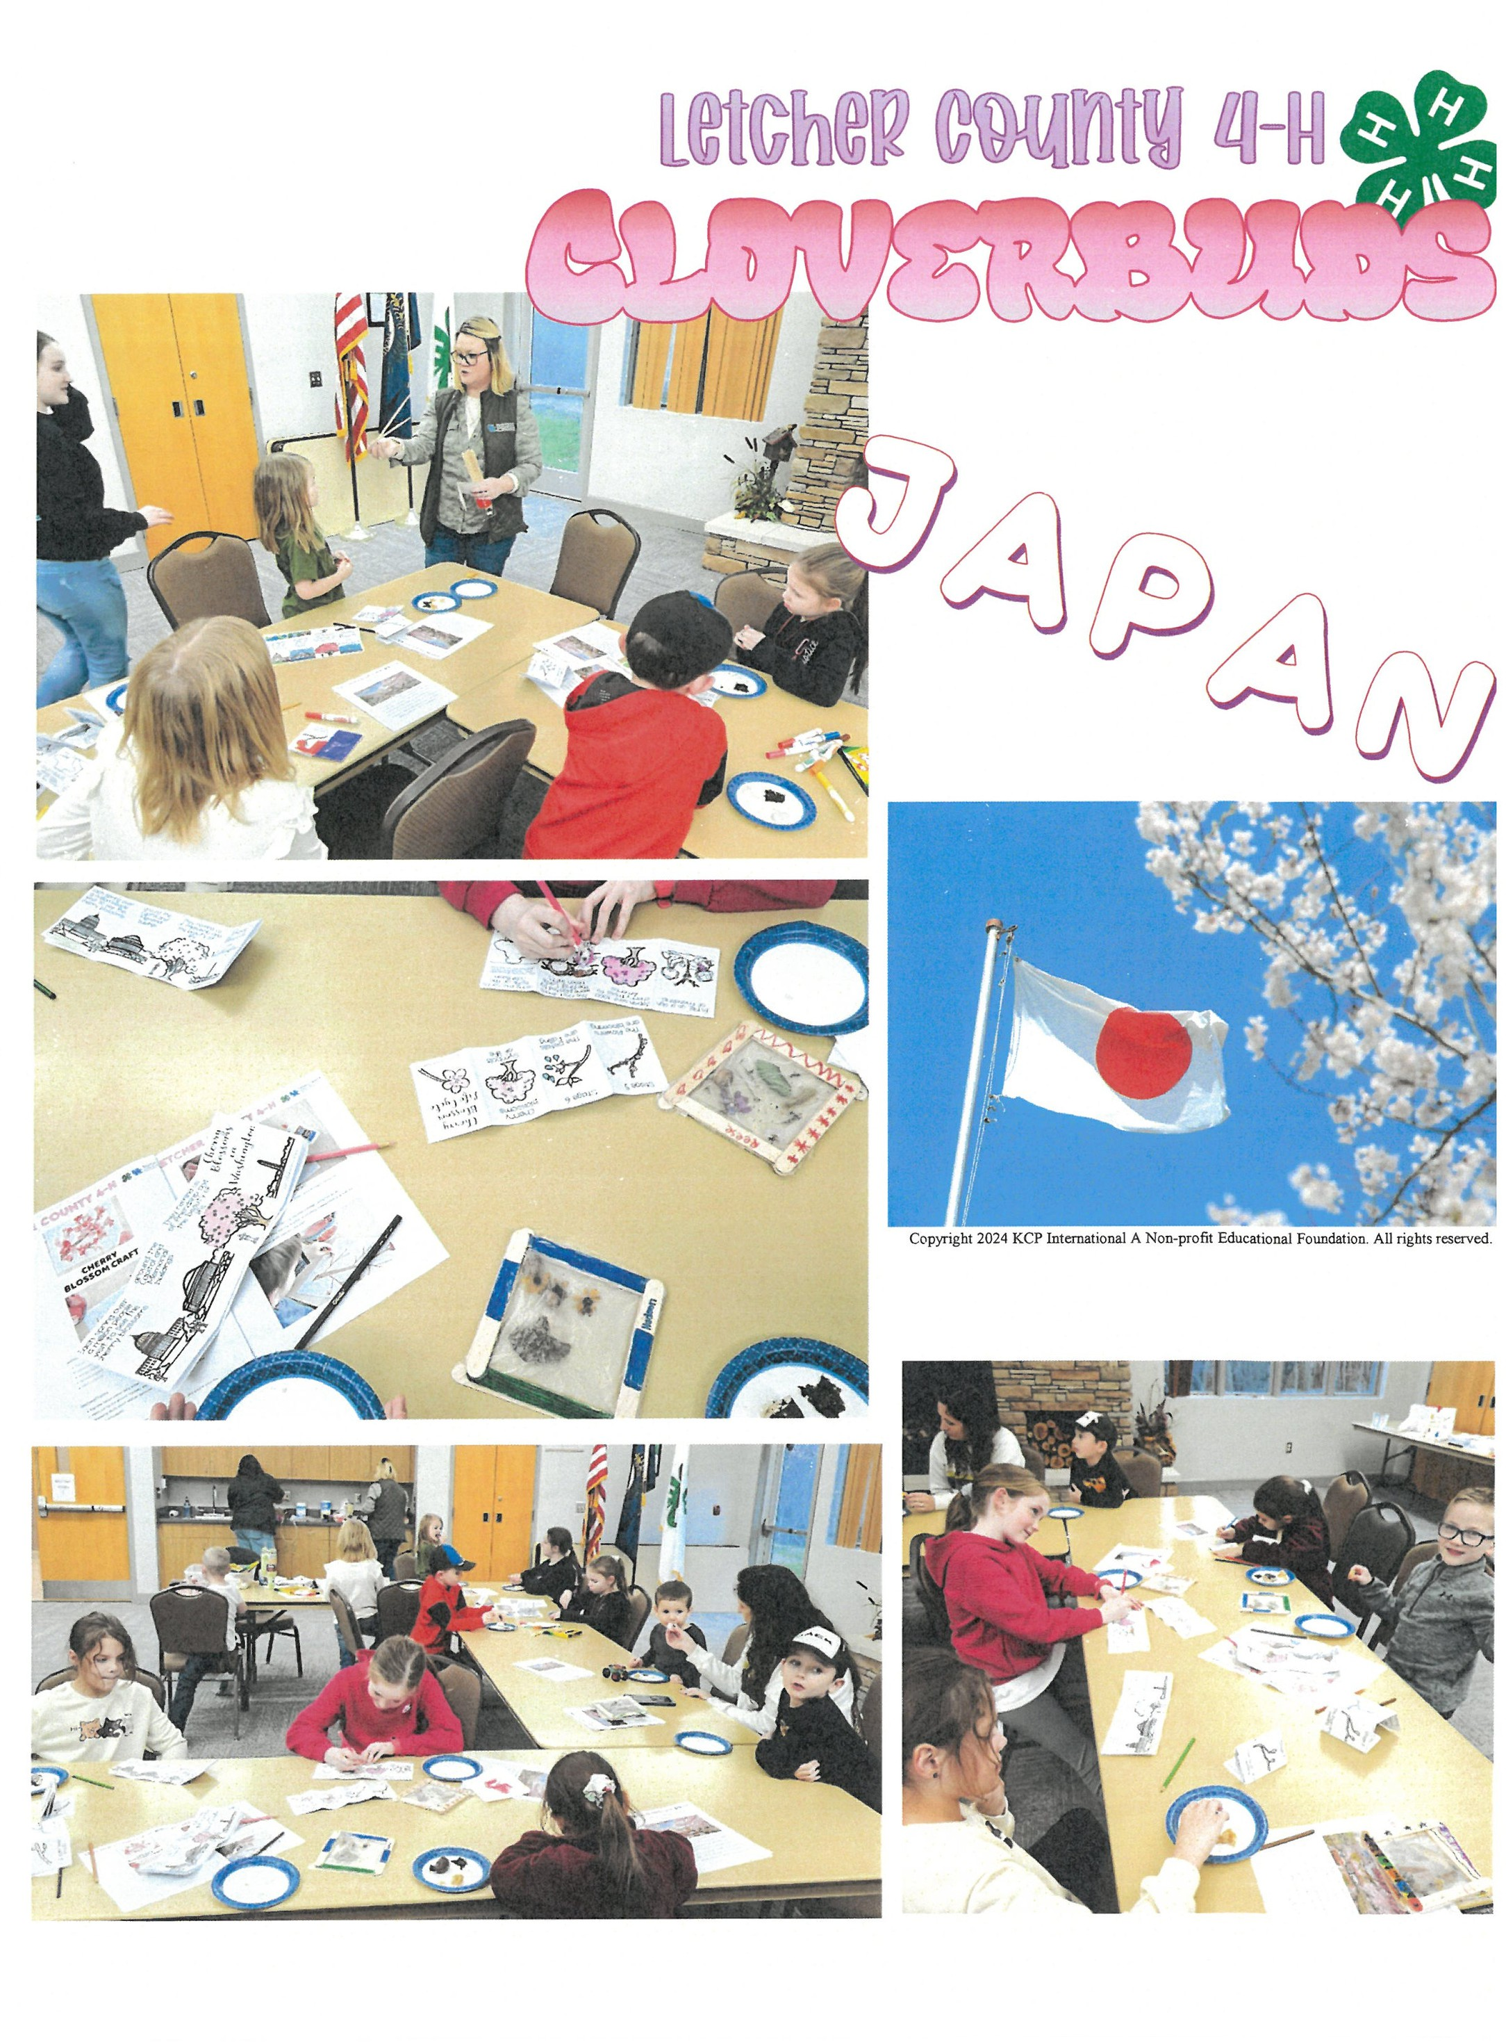

Letcher County Extension 478 Extension Dr
Po Box 784
Whitesburg, Ky 41858 Return Service Requested

